Wollo University
COLLEGE OF INFORMATICS
DEPARTMENT OF SOFTWARE ENGINEERING
Group Assignment For Requirement Engineering

Group Members | ID Number
Hubeyb Awol | 1067/16
Kidanework Yirga | 1152/16
Mahlet Chanyalew | 3963/16
Mena Mulugeta | 1320/16
Murad Bzuneh | 1492/16

Tripful Travel Agency
Software Requirement Specification
For
Travel agency website

Version 1.1

Prepared by: Group 1

Data created: 20/04/2018

Table Of Contents
1. Introduction 5
1.1 Purpose 5
1.2 Intended Audience and Reading Suggestions 6
1.3 Definitions, Acronyms & Abbreviations 7
1.4 Overview of the Document 9
2. Overall Description 10
2.1 Product Perspective 10
2.2 Product Features/Functions 11
2.2.1 User Registration and Authentication 11
2.2.2 Search for Flights, Hotels, Packages, and Car Rentals 11
2.2.3 Online Booking and Booking Management 11
2.2.4 Secure Payment Processing 11
2.2.5 Reviews and Ratings for Hotels and Packages 11
2.2.6 Administration Dashboard 12
2.3 User Classes and Characteristics 12
2.4 General Constraints 13
2.5 User Documentation 14
2.6 Assumptions and Dependencies 15
3. Specific Requirements 16
3.1 User Requirement 16
3.1.1 Functional Requirement 16
3.1.2 Non-functional Requirement 23
3.2 System Requirements 27
4. External Interface Requirements 29
4.1 User Interfaces 30
4.1.1 Overview of User Interfaces 30
4.1.2 General GUI Standards 31
4.1.3 Customer Interfaces 32
4.1.4 Staff and Administrator Interfaces 34
4.2 Hardware Interfaces 34
4.2.1 Overview 34
4.2.2 Supported Devices 34
4.2.3 Hardware Interaction 35
4.3 Software Interfaces 35
4.3.1 Overview 35
4.3.2 Database Interface 35
4.3.3 Payment Gateway Interface 36
4.3.4 Email Notification Interface 36
4.3.5 Mapping Service Interface 36
4.4 Communication Interfaces 37
4.4.1 Web Communication 37
4.4.2 Email Communication 37
4.4.3 Security and Encryption 37
4.4.4 Error and Alert Communication 38
5. Analysis Models 39
5.1 System Use case Model 39
5.2 Sequence Diagram 40
5.2.1 Edit Booking Sequence Diagram 40
5.2.2 Payment Process Sequence Diagram 43
5.2.3 Registration Sequence Diagram 45
5.3.4 Search Booking Sequential Diagram 47
5.3.5 Review Submission Sequence Diagram 49
5.3 Activity diagram 50
5.3.1 Edit Bookings Activity Diagram 50
5.3.2 Payment Process Activity Diagram 52
5.3.3 Search Booking Activity Diagram 54
5.3.4 User Registration Activity Diagram 56
5.3.5 Review Submission Activity Diagram 58
6. Reference 60
Appendix: Requirements Gathering Documentation 61
1. Stakeholder Interview Questions 61
2. User Requirements Questionnaire 61
3. Technical & Constraint Checklist 61
4. Interface Requirements Survey 62

1. Introduction

1.1 Purpose
Our Tripful website WILL:

- Let Customers:
- See packages based on their choice and book them.
- Search and book trips or travels.
- Booking and payment.
- Create an account.
- See their bookings, edit and cancel them.
- View Destination.
- See Ratings & Give Review.
- Search Services.
- Let Staff (Travel Agents):
- Add new holiday packages to the website or Edit package.
- See everyone's bookings.
- Update booking details.
- Respond to the Customer Request.
- Let System Admin
- Manage User.
- Manage all Bookings.
- Backup Data.
- System Monitoring.

- Our Tripful website will NOT:
- Send physical tickets by mail (everything is online).
- Book things like concert tickets (only rental cars(ride) /flights/hotels).
- Work as a phone app (it's a website that works on phones/computers).
- Talk directly to airline computers (we'll enter package details manually for now).

- Simple Goal:
- Make booking a holiday as easy as ordering food online!

1.2 Intended Audience and Reading Suggestions

Who Is This Document For?
- Developers (Coders) - To know exactly what to build.
- Designers - To understand what pages and features to design.
- The Project Manager - To track what needs to be done.
- Testers (a team member) - To check if we built everything correctly.

What's in This Document & How to Read It?

Think of this document as a recipe book for building our website. The following shows what’s inside:

Part 1: The Overview (What you're reading now)

- Section 1.1: Why we're building the website and what it will/won't do.
- Section 1.2: This section – who should read it and how.

Part 2: The Detailed Plan

- Section 2: A full list of every feature the website needs, from most to least important.
- Section 3: How the website should look and feel (colors, layout, etc.).

- Suggested Reading Order
- Read Section 1.1 (Purpose & Scope) first. This tells you the main goal.
Then, Depending on Your Role:

- If you are a Developer/Coder: Go straight to Section 2. This is your main checklist for building.
- If you are a Designer: Read Section 2 to know the features, then focus on Section 3 for design rules.
- If you are the Project Manager: Read the entire document to understand the full plan.

1.3 Definitions, Acronyms & Abbreviations

This section explains simple technical words we will use in this document. Think of it as a mini-dictionary for our project.

Basic Website Terms

Term | What it means for our project
Website / Web App | Our Tripful site that runs in a browser (like Chrome).
Front-end | The part users see and click on (colors, buttons, pages).
Back-end | The hidden part that saves data and makes things work.
Database | A digital filing cabinet where we store bookings and packages.
Admin Panel | A special page only our staff can access to manage bookings.

Common Acronyms

Acronym | Full Name | What it means
SRS | Software Requirements Specification | This document - our project's instruction manual.
UI | User Interface | How the website looks (buttons, menus, layout).
UX | User Experience | How easy and pleasant the website is to use.
URL | Uniform Resource Locator | The website address (e.g., www.traveleze.com).
API | Application Programming Interface | A way for our website to talk to other services.

Project-Specific Terms

Term | Meaning in our travel website
Package / Tour Package | A holiday deal (flight + hotel + activities together)
Booking Request | A form a customer submits to reserve a package
Customer / User | A person visiting our website to book a holiday
Staff / Admin / Agent | Our travel agency employees who manage the website

The important of the above things is:-
- Prevents confusion - Everyone understands the same words the same way.
- Helps communication - When we say "front-end," we all mean the visible website.
- Makes planning easier - Clear terms help us break down the work.

1.4 Overview of the Document

a) What This Document Contains

This document is the complete plan for building the Tripful website. Think of it as your project's instruction manual or recipe book.

It includes:-

- The "Why" - Why we are building this website and its main goals.
- The "What" - A complete list of every feature the website needs
- The "How it Looks" - Guidelines for how the website should appear (design, colors, layout).
- Rules & Terms - Simple explanations of technical words and how we label important features

b) How This Document Is Organized

The document is divided into four main parts, from general to specific:

PART 1: INTRODUCTION (What you're reading now)
- 1.1 Purpose & Scope → Why we're building this and what it will do.
- 1.2 Intended Audience → Who should read which parts.
- 1.3 Definitions → Simple dictionary of technical words.
- 1.4 Overview → This section explains the document.

PART 2: REQUIREMENTS (THE MOST IMPORTANT PART)
- 2.1 Overall Description → How the website works as a whole.
- 2.2 Specific Requirements → Detailed checklist of every feature.

PART 3: DESIGN & CONSTRAINTS
- 3.1 User Interface → How the website should look.
- 3.2 Technical → Any technical rules we must follow.
- 3.3 Future Ideas → Features we might add later.

PART 4: APPENDICES (Extra helpful info)
Any extra diagrams, references, or examples.

2. Overall Description

2.1 Product Perspective

A Tripful- Travel Agency Website is a new web application designed to digitalize traditional travel agency operations and modernize travel booking. Unlike other systems that require manual booking processes, Tripful offers users an easy and straightforward way to access everything they need.

The system integrates with a third-party mapping service to display interactive maps showing hotel locations, destinations, and nearby attractions. And also it works with third-party payment gateways through secure APIs to handle online transactions, and it also links up with an email notification service to automatically send out booking confirmations, cancellations, and password recovery emails to users.

2.2 Product Features/Functions

2.2.1 User Registration and Authentication
The system lets users set up a personal account by simply using a valid email address and a password. Authentication mechanisms ensure that only authorized users can access their accounts. Secure login and logout functionality protects user information and prevents unauthorized access. Password recovery features are provided to help users regain access if credentials are forgotten.

2.2.2 Search for Flights, Hotels, Packages, and Car Rentals
The system offers a powerful and user-friendly search interface where users can easily search available flights, hotels, travel packages, and car rental services. Users can enter search criteria such as destination, travel dates, and budget. The system quickly displays the best options available, making it simple for users to find exactly what they need to plan their trip and help them to compare available options easily..

2.2.3 Online Booking and Booking Management
Registered users can select travel services and complete bookings through the system. With the booking management feature, users can easily check their booking history, monitor the status of their reservations, and cancel bookings if needed. The system makes sure that all booking details are accurately stored and updated in real time. This feature reduces manual effort and provides users with full control over their travel plans.

2.2.4 Secure Payment Processing
The system works seamlessly with a reliable third-party payment gateway to ensure that online payments are processed safely. All payment transactions are conducted over encrypted connections, and sensitive financial information is handled only by the payment provider. Payment confirmation is received by the system to finalize bookings. This setup guarantees data privacy, security, and adherence to online payment standards.

2.2.5 Reviews and Ratings for Hotels and Packages
The system lets registered users share their experiences by submitting reviews and ratings for hotels and travel packages they have used. Users can also read reviews from other travelers. This feature helps improve transparency and user trust and helps users to make well-informed choices.

2.2.6 Administration Dashboard
The system provides an administrative dashboard that allows administrators to manage bookings, users, reviews, and travel content. The admin can easily update booking statuses, monitor system activity, and make sure everything runs smoothly on the platform.

2.3 User Classes and Characteristics

User class | Characteristics | Main activities | Access level
Guest users | Users who access the system without creating an account | Browse destinations, search flights, hotels, packages, and car rentals | Read-only access
Registered users | Users who have created an account and logged into the system | Book, cancel, and manage bookings, make payments, leave reviews and ratings | Standard user access
Travel Agency Staff | Employees of the travel agency who manage travel-related operations | Manage bookings, update travel packages, manage hotel and flight information, respond to customer issues | Limited administrative access
System Administrators | Technical administrators responsible for system maintenance and security | Manage user accounts, control system settings, monitor security, perform backups | Full system access

2.4 General Constraints
This section outlines the technical, operational, and security limitations that shape the design, development, and deployment of the Tripful Travel Agency Website. These constraints set the boundaries within which the system must function.
- Browser Compatibility Constraint
The system needs to operate correctly on modern web browsers, especially Google Chrome. This requirement guarantees that users experience consistent functionality, user interface behavior, and performance across all supported browsers. Developers should use standardized web technologies like HTML5, CSS3, and JavaScript, to avoid any browser-specific features that might lead to compatibility headaches.
- Internet Connectivity Constraint
A reliable internet connection is essential for all system operations. Since the Tripful Travel Agency Website is a web-based application, users must be online to access features like searching for travel services, making bookings, processing payments, and receiving notifications. The system also depends on internet connectivity to interact with third-party services such as payment gateways, email services, and mapping APIs.
- Secure Payment Gateway Constraint
The system must use secure, certified third-party payment gateways for all financial transactions. This requirement ensures that sensitive payment information is managed by trusted providers who adhere to financial security standards. The system itself should not store any credit or debit card details, minimizing the risk of data breaches and ensuring compliance with payment industry regulations.
- Web Security Standards Constraint
System development must follow recognized web security standards to protect user data and system resources. These standards include secure authentication, password hashing, encrypted data transmission via HTTPS, protection against common web threats (like SQL injection and cross-site scripting), and effective access control mechanisms. By adhering to these standards, we can ensure data confidentiality, integrity, and overall system reliability.

2.5 User Documentation

We are excited to provide user documentation alongside the Tripful Travel Agency Website to cater to various user needs and ensure everyone can make the most of the system:

User Guide (Online Manual)
- This guide offers clear, step-by-step instructions for everything from user registration and logging in to searching for flights, hotels, packages, and car rentals.

- It walks you through the booking process, payment steps, how to cancel a booking, and how to view your booking history.

- You can access it in digital format (HTML/PDF) right from the website.

Admin Manual
- This manual outlines the administrative functions, including how to view, manage, update, and cancel user bookings.

- It also provides guidance on monitoring user activities and managing system notifications.

- This document is delivered in PDF format and is intended for authorized administrators only.

Online Help and Tooltips

- You'll find context-sensitive help messages and tooltips integrated into the user interface.

- These features are designed to assist you while filling out forms, filtering searches, and completing payment processes.

FAQs (Frequently Asked Questions)

- This section addresses common questions users might have about account management, bookings, payments, and reviews.

- You can access it directly from the website.

Email Notifications and Guides

- We send automated emails for account registration, password resets, booking confirmations, cancellations, and updates.

- These emails include concise instructions and links to the relevant pages in the system.

All user documentation is crafted in straightforward, clear language, making it easy for users with basic computer and internet skills to understand, and it will be kept up-to-date with system changes.

2.6 Assumptions and Dependencies
The key conditions assumed to be true and the external factors that play a crucial role in the successful operation of the system. While these assumptions and dependencies are beyond our direct control, they can have a significant impact on how well the system functions and performs.
User Email Availability Assumption
The system assumes that every user has access to a valid and active email address. This is important because email is necessary for key system functions like account registration, email verification, password recovery, and booking notifications. If users do not have access to email or provide incorrect email addresses, certain system features may not function as intended.
Third-Party Payment Gateway Dependency
Our system relies on third-party payment gateway services to securely and reliably process online transactions. The availability, performance, and accuracy of payment processing are managed by these external providers. If there is any downtime, delay, or failure in the payment gateway, it could temporarily stop users from completing their bookings, even if everything else in the system is running smoothly.
Hosting Infrastructure Dependency
The system depends on hosting servers to deliver the necessary performance, storage capacity, and uptime. We need proper server resources to manage user traffic, store booking and user data, and ensure quick response times. Any server outages, lack of resources, or network issues could negatively affect system availability and the overall user experience.

3. Specific Requirements
This section details the functional and non-functional requirements for the Tripful Travel Agency Website, organized by user roles and system features for clarity and traceability.

3.1 User Requirement
User requirements describe what the system should do from the perspective of the end-users (customers, staff, administrators).

3.1.1 Functional Requirement

Functional requirements define the specific behaviors, features, and tasks the system must perform. They are grouped by user role and system capability.

GROUP A : CUSTOMER ACCOUNT AND AUTHENTICATION

Requirement ID | REQ-1
Requirement | User Registration
Description | A user must be able to create a personal account by providing a valid email address and a secure password
Source | Section 2.2.1 ( User Registration and Authentication )
Priority | High
Related Requirements | REQ-2, REQ-3, REQ-5

Requirement ID | REQ-2
Requirement | Secure Login & Logout
Description | Description The system should allow registered users to log in and log out of the system securely.
Source | Section 2.2.1(User Registration and Authentication)
Priority | High
Related Requirements | REQ-1, REQ-4

Requirement ID | REQ-3
Requirement | Password Recovery
Description | Users should be able to recover their account password through a secure email link.
Source | Section 2.2.1 (User Registration and Authentication)
Priority | Medium
Related Requirements | REQ-1

Group B: Customer Search & Booking

Requirement ID | REQ-4
Requirement | Browse & Search Packages
Description | All users, whether guests or registered users, must be able to search holiday packages based on the holiday package location, date, and budget
Source | Section 2.2.2 ( Search for Flights, Hotels, Packages, and Car Rentals)
Priority | High
Related Requirements | REQ-5

Requirement ID | REQ-5
Requirement | Online Booking
Description | Registered users should be able to pick a package and proceed to make a booking.
Source | section 2.2.3( Online Booking and Booking Management )
Priority | High
Related Requirements | REQ-4, REQ-6, REQ-7

Requirement ID | REQ-6
Requirement | Room Booking
Description | Registered users should be able to find their list of bookings, view the status of bookings, and remove bookings.
Source | Section 2.2.3( Online Booking and Booking Management )
Priority | High
Related Requirements | REQ-5

Group C: Customer Payment & Feedback

Requirement ID | REQ-7
Requirement | Hard Payment Execution
Description | The payment process needs to be secured through an integrated third-party payment gateway.
Source | Section 2.2.4 ( Secure Payment Processing )
Priority | High
Related Requirements | REQ-5

Requirement ID | REQ-8
Requirement | Submit Reviews & Ratings
Description | Registered users should have the ability to write reviews and ratings about the hotels and packages they have booked.
Source | Reviews and Ratings for Hotels and Packages
Priority | Medium
Related Requirements | REQ-5, REQ-6

Group D: Staff & Administrative Functions
Requirement ID | REQ-9
Requirement | Admin Dashboard Access
Description | Employee access to the administrative dashboard to be able to manage bookings, packages, and users.
Source | Administration Dashboard
Priority | High
Related Requirements | REQ-10, REQ-11

Requirement ID | REQ-10
Requirement | Manage Holiday Packages
Description | The staff should be able to enter, edit, and delete holiday packages (flight and hotel).
Source | Section 1.1 (purpose)
Priority | High
Related Requirements | REQ-9

Requirement ID | REQ-11
Requirement | View All Bookings
Description | Staff members have to be able to access and search all customer bookings.
Source | Section 1,1 (purpose)
Priority | High
Related Requirements | REQ-9, REQ-6

3.1.2 Non-functional Requirement

Non-functional requirements define how the system should perform, focusing on quality attributes like security, usability, and reliability.

Group A: Security & Compliance

Requirement ID | NFR-1
Requirement | Secure Authentication & Data Protection
Description | The system must implement secure login, password hashing, HTTPS, and protection against common web threats (SQL injection, XSS).
Source | Section 2.4 ( General Constraints )
Priority | High

Requirement ID | NFR-2
Requirement | PCI DSS Compliance (No Card Storage)
Description | The system must NOT store credit/debit card details. All payments must be handled by a certified third-party gateway.
Source | Section 2.4 ( General Constraints)
Priority | High

Group B: Usability & Compatibility
Requirement ID | NFR-3
Requirement | Cross-Browser Compatibility
Description | The website must function correctly on modern browsers (Chrome, Firefox, Safari, Edge) using standard HTML5, CSS3, and JavaScript.
Source | Section 2.4 (General Constraints)
Priority | High

Requirement ID | NFR-4
Requirement | Responsive & Mobile-Friendly Design
Description | The website must be fully functional and visually consistent on desktop, tablet, and mobile devices.
Source | Section 1.1 (purpose)
Priority | High

Group C: Performance & Dependencies

Requirement ID | NFR-5
Requirement | Internet Dependency
Description | All core functions (search, booking, payment) require an active internet connection.
Source | Section 2.4 (General Constraints)
Priority | High

Requirement ID | NFR-6
Requirement | Third-Party Service Integration
Description | The system must integrate with: 1) Payment Gateway, 2) Email Service, 3) Mapping API.
Source | Section 2.6
Priority | High

3.2 System Requirements

The system requirements explain how each functional requirement is to be met, including how to treat errors and what the system response should be.

REQ-1 (User Registration )

The system shall support email format validation.
Passwords must be hashed with bcrypt or equivalent methods.
After a successful registration, the system should send a verification email.

REQ-4 (Browse & Search Packages):

The search interface must support filtering for destination, date, price, and type of package.

<p style="text-indent: 1em;">
“Results will contain numerous pages. Results will need

If nothing matches the packages, the system should also display: "No packages found. Try adjusting your filters."

REQ-5 (Online Booking)

Only logged-in users will be able to book (REQ-2).
The System will display a summary page before confirming the payment.
The status of the booking will be marked as "Pending" until the payment status is confirmed.

REQ-7 (Secure Payment Processing):

The system shall redirect the user to a third party payment page.
On successful payment, the system will update the booking status to "Confirmed" and send a confirmation email.
If the payment fails, the system shall hold the booking as “Pending” and alert the user.

REQ-9 (Admin Dashboard Access):

Access shall be restricted to those with "Staff" or "Admin" roles.
- There will be a presence of modules named Bookings, Packages, Users,
- All admin operations must be recorded in an audit trail.
- Error Handling:
- Invalid login attempts shall result in account lockdown.
- Payment/email API failures will generate a system alert. There will be an entry in the log for the error.
- All user-visible error messages must be user-friendly and non-technical.

Essential Use Case Diagram
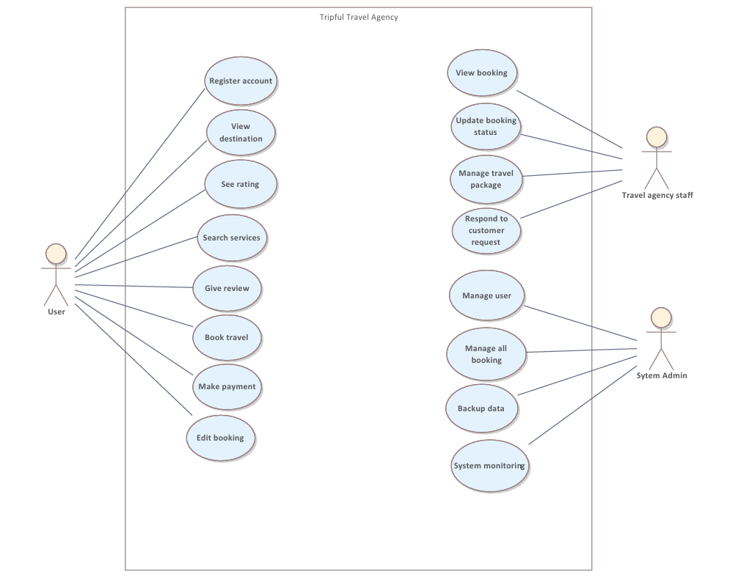

4. External Interface Requirements
This section explains how the Tripful Travel Agency Website communicates with users, user devices, external software systems, and the internet.
It clearly shows how information enters the system (user input, payments, searches) and how information leaves the system (search results, confirmations, emails).
These interfaces are important because they ensure:
- Smooth interaction between users and the system
- Secure handling of sensitive data
- Reliable communication with external services
The detailed screen design (colors, buttons, fonts, layouts) will be documented separately in a User Interface Design document, so this section focuses only on how the system interacts, not how it looks.

4.1 User Interfaces

4.1.1 Overview of User Interfaces
Tripful is a web-based system, which means users do not need to install any application.
They can access the system using a web browser such as Google Chrome on:
- Desktop computers
- Laptops
- Tablets
- Smartphones
This approach is suitable for Ethiopia, where many users rely on smartphones for internet access.
The system follows simple and familiar design rules, so even users with limited technical knowledge can use it comfortably.
Different users see different screens, based on their role, which improves both security and usability:
- Guest Users – browse packages only
- Registered Customers – book and manage trips
- Travel Agency Staff – manage bookings and packages
- System Administrators – manage system settings and security
Each user can only access the functions they are authorized to use, preventing misuse of the system.
Ethiopia real-world example:
This works like Ethiopian Airlines’ website:
- Passengers can search and book flights
- Airline staff use a separate internal system to manage reservations

4.1.2 General GUI Standards
All pages in Tripful follow the same Graphical User Interface (GUI) standards to keep the system consistent and easy to learn.
These standards include:
- Same header, navigation menu, and footer on every page
- Responsive design so the layout adjusts automatically on phones and computers
- Standard menu items available across the system:
  - Home
  - Search Trips
  - Login / Logout
  - My Bookings
  - Help / FAQ
Additional usability rules:
- Clear text and readable font size
- Good color contrast for visibility
- Simple error messages written in non-technical language
- Confirmation messages before important actions to avoid mistakes
Example:
If a user enters the wrong password, the system shows:
“Invalid email or password. Please try again.”
This helps users correct the problem without confusion.

4.1.3 Customer Interfaces
a) Home and Search Interface
This is the main entry point for users.
It allows users to:
- View available holiday packages
- Search using filters such as:
  - Destination
  - Travel date
  - Budget
This interface is available to both guest users and registered users, encouraging exploration before registration.
Example:
A user searches:
“Harar – August – Budget under 70,00 ETB”
The system quickly shows matching travel packages.

b) Registration and Login Interface
This interface handles user identity and security.
It allows users to:
- Create an account using email and password
- Log in securely
- Recover passwords through email
This ensures only authorized users can access personal bookings.
Example:
Like Telebirr or Chapa, users receive a secure password reset email.

c) Booking and Payment Interface
This interface handles the core business function of Tripful.It:
- Displays booking details before payment
- Shows booking status (Pending or Confirmed)
- Redirects users to a secure third-party payment system
This reduces booking errors and increases user trust.
Example:
Similar to ordering food online in Addis Ababa:
You review the order first, then complete payment.

d) User Dashboard
The dashboard gives users full control over their bookings.
Users can:
- View booking history
- Cancel bookings when allowed
- Submit reviews and ratings
This improves transparency and customer satisfaction.
Example:
Like Ride or Feres, users can view past trip history.

4.1.4 Staff and Administrator Interfaces
a) Administrative Dashboard
This interface is restricted to authorized staff and administrators only.
It allows them to:
- Manage customer bookings
- Add, update, or remove travel packages
- Manage user accounts
- Monitor reviews
This interface helps staff operate the travel agency efficiently.
Ethiopia example:
Similar to hotel management systems used by hotels in Addis Ababa.

4.2 Hardware Interfaces

4.2.1 Overview
Tripful does not require any special hardware devices.
All interaction is done using standard user devices and web browsers.
This reduces cost and makes the system widely accessible.

4.2.2 Supported Devices
- Desktop computers
- Laptops
- Tablets
- Smartphones

4.2.3 Hardware Interaction
- Input: keyboard, mouse, touchscreen
- Output: screen display
- No printers, scanners, or card machines are required
Ethiopia example:
A user checks packages on a smartphone while commuting, then books later on a laptop at home.

4.3 Software Interfaces

4.3.1 Overview
Tripful integrates with other software systems using secure APIs to provide full functionality.

4.3.2 Database Interface
The database stores all important system data:
- User accounts
- Bookings
- Travel packages
- Reviews
Example:
When a booking is confirmed, the database updates immediately.

4.3.3 Payment Gateway Interface
The system connects to trusted third-party payment services.
Important points:
- Tripful does not store card details
- Payments are handled securely by external providers
Example:
Similar to paying online using local bank cards or mobile payment platforms.

4.3.4 Email Notification Interface
Email communication is used for:
- Account verification
- Password recovery
- Booking confirmation and cancellation
Example:
Like confirmation emails from Ethiopian Airlines.

4.3.5 Mapping Service Interface
Maps help users:
- See hotel locations
- Identify nearby attractions
Example:
Like Google Maps showing hotels around Bole Airport or Piazza.

4.4 Communication Interfaces

4.4.1 Web Communication
- Uses HTTP and HTTPS
- HTTPS is mandatory for security
- All data is encrypted during transmission
Example: The lock icon in the browser shows secure communication.

4.4.2 Email Communication
Emails include:
- Clear subject line
- Booking reference number
- Useful links

4.4.3 Security and Encryption
- Secure authentication
- Encrypted data transfer
- Safe password reset links
Example: Same level of security used by online banking services in Ethiopia.

4.4.4 Error and Alert Communication
- Errors are stored in system logs
- Administrators receive alerts
- Users see friendly messages
Example:
“Payment service is temporarily unavailable. Please try again later.”

Conclusion
The External Interface Requirements ensure that Tripful:
- Is easy to use for Ethiopian users
- Works on common devices
- Integrates safely with payment, email, and map services
- Protects user data and privacy
Overall, Tripful provides a secure, user-friendly, and reliable travel booking system suitable for real-world use in Ethiopia.

5. Analysis Models

5.1 System Use case Model

Introduction

The diagram lays out the functional structure and user roles within Triptul Travel Agency, a digital platform designed for all travel needs. It clearly shows how different users like customers and staff interact with the system’s main features. The diagram is neatly divided into three key areas: customer-facing features , staff administrative functions, and system management roles. This setup emphasizes how the agency facilitates travel planning, booking, and management, all while keeping everything running smoothly and securely.

Narrative description

Triptul Travel Agency is a comprehensive online travel platform, designed to make planning and management processes for both customers and agency staff.

For customers, the system starts with easy account registration. Once they are in, they can explore various destinations, check out ratings, and search for services like flights, hotels, and tour packages. When they find what they love, booking travel is simple, and they can even make payments and tweak their bookings later if needed. After their journey, the system encourages users to share their experiences through reviews, helping to build a vibrant community of travelers.
For Travel Agency Staff, the system has an admin interface. This is where they can update booking statuses, manage travel packages, respond to customer inquiries, and keep track of all bookings.
For System administrators they can handle user management, back up data, and monitor the system to ensure everything runs smoothly and securely.

The platform has three key roles within the Travel Agency Staff:
- System Admin: Oversees the entire system, ensuring security and maintenance.
- Server: Manages the backend infrastructure and data flow.
- Service: Takes care of travel services, updates packages, and guarantees quality.
- User: Refers to staff members who access the admin panel for daily operations.
.

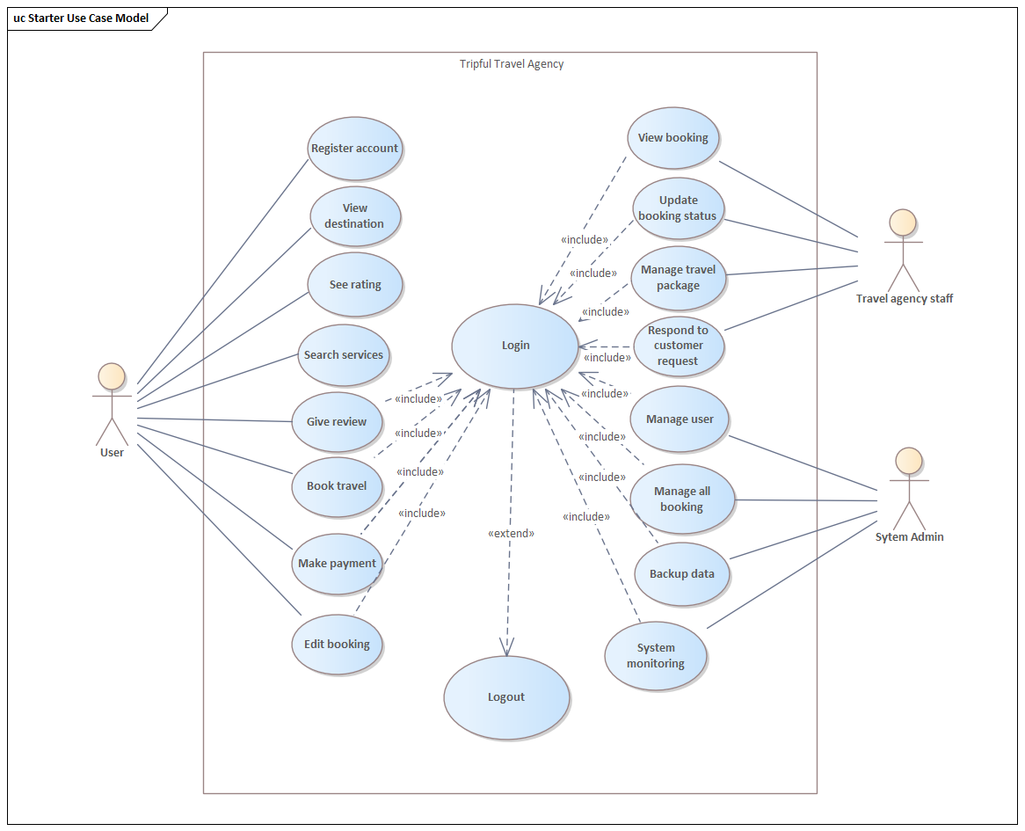

5.2 Sequence Diagram

5.2.1 Edit Booking Sequence Diagram

Introduction
This sequence of steps shows the order in which the User interacts with the Website (the System Interface) and the Database to edit an existing reservation. This sequence outlines the real-time exchange of messages as they are sent back and forth from the moment the user initiates an edit on the reservation until the system confirms that the edit was successful. This sequence also indicates how the system should behave and demonstrates the interaction(s) between the front-end and back-end components of the system. The sequence also ensures that the user receives adequate feedback and that data integrity will be maintained between the front-end systems and the database.

Narrative Description

The interaction begins when a user tries to access the "Edit" booking feature. If the user is not already authenticated, they send a "Login" request to the website, which verifies and grants access to the user after successful verification.
Once access is granted, the user navigates to "My Bookings" and the website sends a "Get User's Bookings" request to the database. The database responds with the bookings associated with the user and the website displays the list of bookings for the user.
To edit a specific booking, the user clicks on the "Edit" option next to the booking. The website sends a "Get Details for Booking" request to the database. The database returns all details, including the dates, the number of people, and the package type for that booking. The website then populates an "Edit form" with the current information for that booking.
The user would then edit one or more fields, including perhaps the date, and click on the "Save" button. This sends an "Update Booking with New Dates" command to the database. After the database confirms that the booking has been successfully updated, the website displays a "Booking Updated Successfully" message, which ends the interaction.

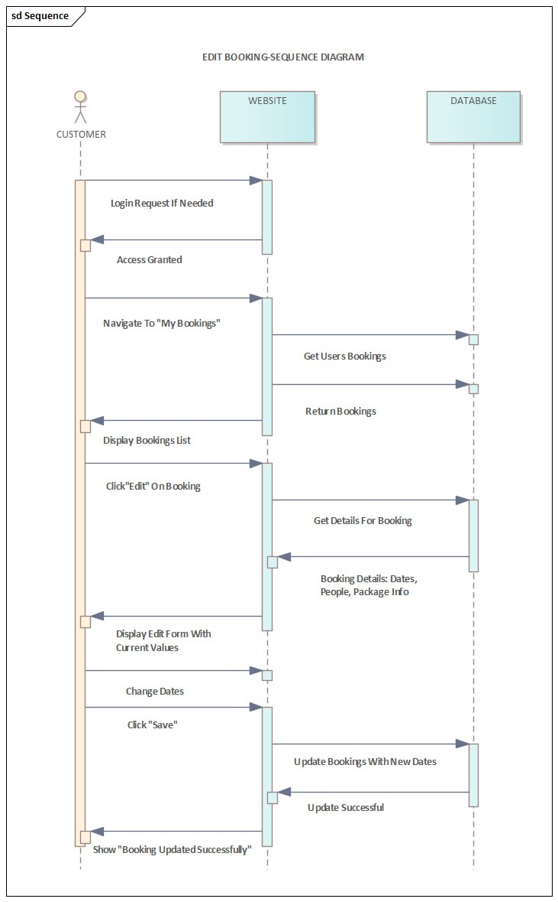

5.2.2 Payment Process Sequence Diagram
Introduction
The Payment Process Sequence Diagram provides a visual representation of the interactions that take place between Customers, Websites, Payment Gateways, and Databases as they go through the Payment phase of a Booking Transaction, specifically for both Telebirr and Chapa payment methods.

This diagram describes how a customer initiates their Payment and how the Customer receives confirmation and Receipts after completion of the transaction. The diagram indicates where external systems are integrated with our system (for example, Payment Gateways), how Customers authenticate themselves, how data is validated, and how the system has updated its state based upon the actions taken during a Payment. These elements allow for the establishment of a secure and traceable payment process that is easy for customers to use.

Narrative Description

Typically, once a customer has completed the booking form and filled in their details on the website, the website will display options for payment and provide the customer with a choice of two possible means of payment, namely, Telebirr and Chapa.
Depending on which option the customer decides to use, the process will follow a different path:

If Telebirr is selected: The customer enters their phone number and clicks the option "Pay with Telebirr." A request for payment is sent to the payment gateway, which in turn generates a USSD or app prompt on the customer's device. The customer will then have to open their Telebirr app and enter their PIN number in order to confirm the payment. Once the customer confirms the payment, the payment gateway will send a payment result to the website, which will allow the website to confirm the payment. After confirming the payment, the website will update the booking status in its database. As soon as the booking status has been updated, the website will display a success page containing the details of the booking and a receipt.

If Chapa is selected:The customer will enter their telephone number or email address and click the button "Pay with Chapa." The website will redirect the customer to the Chapa payment page so that the customer can complete their payment through Chapa's website. Once the payment is successfully completed, Chapa will notify the system of the successful payment, and the system will then proceed to confirm and process the payment. Finally, the system will update the booking status in the database. Once the update has been completed, the website will display a page indicating that the booking has been successfully completed, as well as the details of the booking and a receipt.

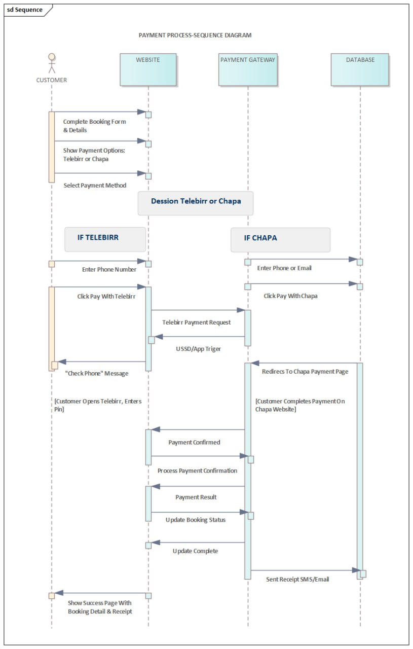

5.2.3 Registration Sequence Diagram

Introduction
The diagram shown illustrates how different parts of a system work together when someone registers for a travel website. It differs from a flowchart because it has grouped all of the steps together in columns called 'lanes' based on which entity they relate to (the User, the Tripful Website, the Backend Server, and Email Services). The diagram shows the complete path of a registration request, showing who has been given responsibility for what at various points in time and what processes happen at the same time in relation to the system's overall architecture.

Narrative Description
The whole process kicks off with the User taking the first step filling out and submitting a form. This simple action sets off a series of events across various system components.

First up, the Tripful Website interface gets the request. Its main job is to pass the user's registration request along to the core application logic. Once it gets the green light from the backend, it takes care of two important tasks for the user: it assigns an account and email (which likely means creating a user session or showing the user their new account details) and displays a confirmation on the screen to let the user know everything went smoothly.

At the same time, the Backend Server, the brain of the system, jumps into action. It handles the essential validation and processing:

Check user: It makes sure the submitted data is unique and intact.

If everything checks out, it sends confirmation instructions to the email services.

It also sends out an invoice, which indicates that the registration might be part of a paid booking or that a transactional receipt (like for a membership) is being generated.

Lastly, the Email Services lane is the specialized subsystem that takes care of external communication. It gets the send instructions from the Backend Server and sends out the actual confirmation email (and probably an invoice) to the email address the user provided. This usually happens in the background while the user is already seeing the confirmation on the website.

The diagram beautifully illustrates a synchronous flow for the user experience (form -> website confirmation) alongside an asynchronous, parallel flow for backend processing and external notifications, all of which are vital for a smooth and professional registration process.

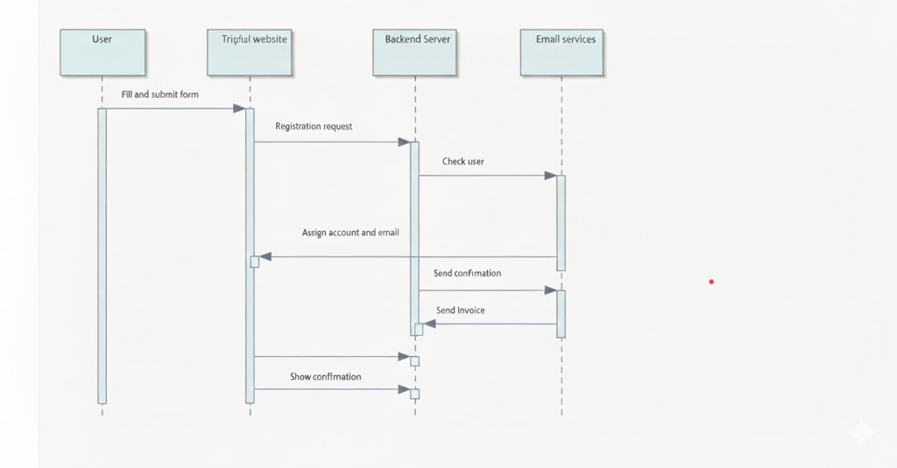

5.3.4 Search Booking Sequential Diagram

Introduction
A cross-functional flowchart depicts how users will interact with various components within the online travel booking system from beginning to end. Users will search for a travel package through the Tripful website (the "user-interface") through the server. They will also utilize other external services (Payment Gateway & Email Service). This cross-functional diagram illustrates how users interact at each step of this e-commerce transaction while demonstrating the dependencies, handoffs, and integration with other systems that an online travel booking site requires.

Narrative Description
The booking process kicks off when the user performs a search for a key package on the travel platform. This action sets everything in motion.

Once the Tripful website gets this request, it jumps into action by conducting a search operation. It then reaches out to the backend to fetch the package data. After retrieving the information, the website displays the results to the user along with a data bar, which likely summarizes the options available.

Next, the user reviews the results and makes a choice, moving on to the selection module probably where they pick a specific package, add-ons, or travel dates. This action prompts the Tripful website to gather and fetch the details for the selected module and send a processing request to the backend server.

The core business logic is managed by the Richard server. It receives the processing request, coordinates with the payment gateway to handle the transaction, and once the payment goes through successfully, it saves the module essentially storing the booking details in a database. The server also starts the confirmation process by sending out confirmation requests.

Following the server's lead, two external services step in:
The payment gateway wraps up the transaction securely.
The email service sends a confirmation email to the user.

In the end, the Tripful website receives a success signal and shows a confirmation message to the user, wrapping up their journey from searching to having a confirmed booking.

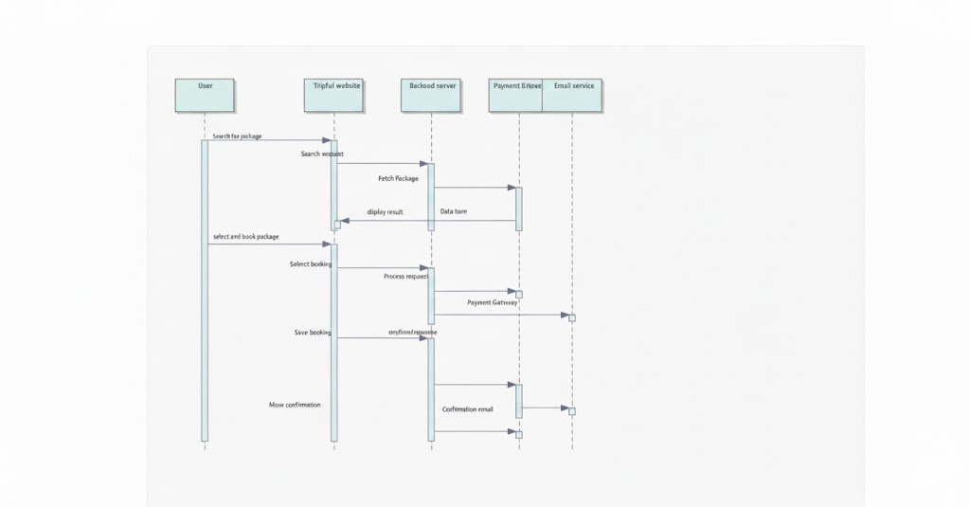

5.3.5 Review Submission Sequence Diagram

Introduction
The provided image describes a Sequence Diagram titled " Review Submission Sequence Diagram." The diagram that visually details how different parts of a system interact in a specific sequence over time. This sequence diagram emphasizes the messages, requests, and responses exchanged between key actors, primarily the user, the website (Tripful), and the database to accomplish the goal of submitting a review. It provides a technical, step-by-step view of the system's behind-the-scenes operations during this process.

Narrative Description
The whole process kicks off when a user decides to load the home page. The Tripful website gets this request and quickly checks the database for the latest reviews. Once the database retrieves the recent reviews, it sends that information back to the website. The website then puts everything together and sends a homepage complete with the reviews section back to the user's browser.

After that, the user engages with the page by scrolling down to the "Share Your Experience" section and clicking on "Share Your Experience." This click sends a signal to the website, which first checks if the user is logged in. In this case, the system finds out that the user isn't logged in.

Since the user hasn't been authenticated yet, the website prompts them to show the login form. The user then clicks the login button, which leads the website to display the login form. The user enters their credentials and logs in, and the website sends this information to the database to verify the user. Once the login is successful, the database confirms this back to the website.

Now that the user is logged in, the website presents the rating form, complete with a star rating and a text field, to the user. The user fills out their review and clicks submit. This submission sends the review data back to the website, which then tells the database to save the new review. The database confirms that the review has been saved.

Finally, the website uses this confirmation to update the homepage review list, likely getting ready to fetch fresh data for future users, and sends a success message back to the user's interface, wrapping up the entire interaction sequence.

5.3 Activity diagram

5.3.1 Edit Bookings Activity Diagram

Introduction
The Edit Bookings Activity Diagram provides a clear visual representation of how users can modify their existing reservations in the system. It breaks down the entire process, showing each interaction between the user and the system from logging in to receiving confirmation of their updates. This diagram is not just a helpful guide for understanding the workflow, it also aids in validating requirements and serves as a valuable resource for developers and testers during the implementation phase.

Narrative Description
The Edit Booking operation starts when a customer accesses the Edit Booking functionality. If the customer hasn't logged in already, they will first be prompted to enter their username and password and log into their account before proceeding to the "My Booking Page" where they can view the listing of current bookings they made with the online booking system.
Next, the system checks whether or not any bookings exist for the user. If no return bookings are found, a "No Return Bookings" message will inform the customer that the operation has ended. If there are bookings associated with the user's account, they can select the specified booking they wish to change, and click on the "Edit" link.
The booking will then be presented to the customer in an editable format so they can update fields like number of guests/visitors, date, room selected, etc. Once they have finished updating the booking with the desired changes, they click on "Save Changes" to save the updates.
Then, the booking will begin processing the updates, and save the updates into the database. Once the updates to the booking have been successfully completed an updated confirmation message will be sent to the customer to let them know their booking has been updated and they have successfully completed the operation.

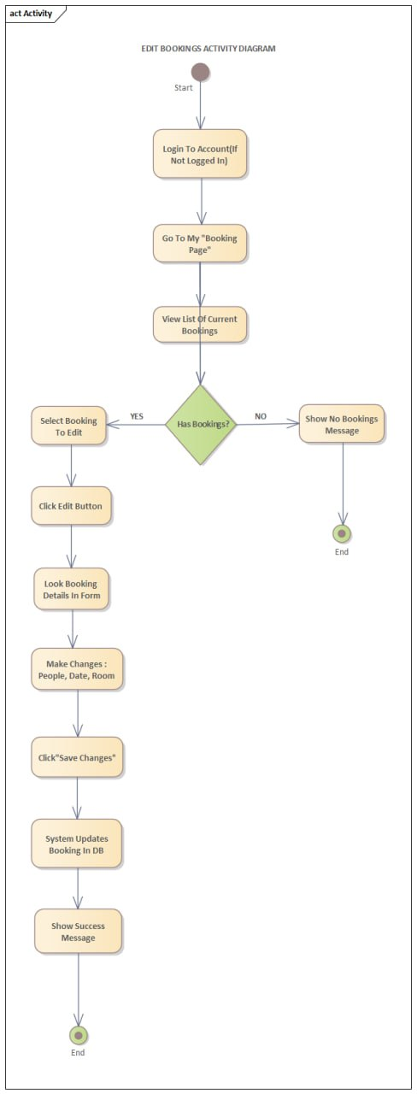

5.3.2 Payment Process Activity Diagram

Introduction
The Payment Process Activity Diagram visually represents how users implement their payment after booking is completed through Telebirr and Chapa. It shows various types of decisions, user actions and system responses at each step of the two choices regarding when to proceed.

This diagram provides a clear image of all steps in the payment process including possible alternative paths (for example "payment failed"), shows how each step in the system was developed, provides information about any missing interaction by a user that might cause problems during payment processing, and supports an accurate understanding of how users experience this payment process and how the system connects to other payment services.

Narrative Description
The payment process begins after the booking form is completed and the user proceeds to payment. At this point, the user will choose a payment method (Telebirr or Chapa).

Depending on which method is chosen:

For Telebirr:
After entering the phone number, the user clicks on "Pay with Telebirr."
The user receives a USSD/App popup requesting entry of the Telebirr PIN to authorize payment.

For Chapa:
The user enters the phone/email and clicks on "Pay with Chapa."
The system redirects to the Chapa payment page, where the user selects their payment option.

After payment authorization, the system checks the payment results.
If payment is successful, it updates the booking to show it is paid for, sends out receipts via SMS/email, displays the success page and ends the process. If payment fails, the system displays a payment failure message, giving the user the option to try a different method. The user can restart payment selection, or exit.

At the end of the activity, either payment has been completed successfully or the user has exited after failing payment attempts.

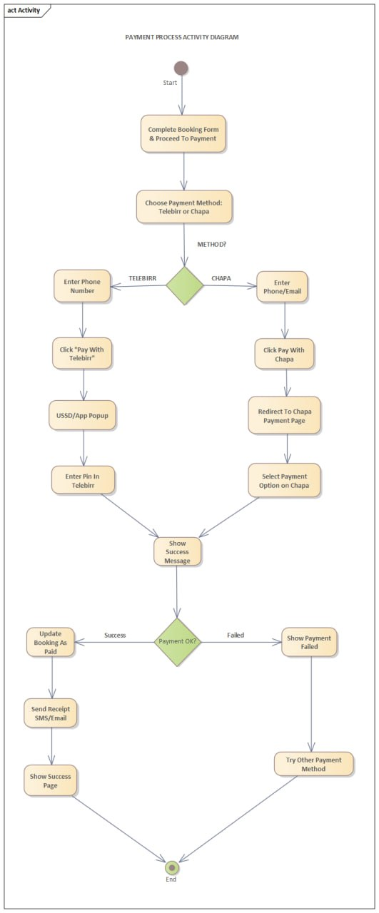

5.3.3 Search Booking Activity Diagram

Introduction

The activity diagram for search and booking illustrates the typical user experience when booking a travel service via Tripful.com. This diagram shows the whole user process, from arriving on the Tripful homepage to searching for services, authenticating as a user, receiving a confirmation of the booking, and paying for the booking. It provides a way to demonstrate to stakeholders and developers how users interact with the Tripful platform in order to successfully complete the booking. The diagram also shows the various options that can be taken along the way, such as logging in before booking or interruptions caused by unsuccessful payment attempts.

This diagram also models a customer's journey through the booking process and depicts where Tripful integrates with different systems in order to successfully book travel services. The diagram helps stakeholders validate the functional requirements that have been established for booking a trip or confirming an existing booking.

Narrative Description

Users start the process by going to the Tripful website. After that, they can Browse or Search to see what kinds of travel options are currently available. After finding the type of service they would like, the user will choose Travel Services so that they can book their trip.
Next, the system will check if the user is Logged in:
If they are not Logged in, then they are prompted either to Register or Log In before proceeding.
If the user is already Logged In, they will be directed immediately to enter in the booking information.
Once the user has completed the required fields, they are then given a summary to Review and Confirm their Booking. The payment process will then be initiated once the booking has been confirmed.

The system will check to see if the payment was successful:
If the payment was successful, then the booking will be Saved and an Email Confirmation will be sent to the user, which will conclude the activity.
If the payment failed, the user will have the option to Retry Payment or Cancel the booking. If the user decides to retry, they will be taken back to payment; otherwise, the activity will end with no booking being saved.

The activity will conclude either when a successful booking confirmation and confirmation email is received or when the payment fails and the booking is cancelled.
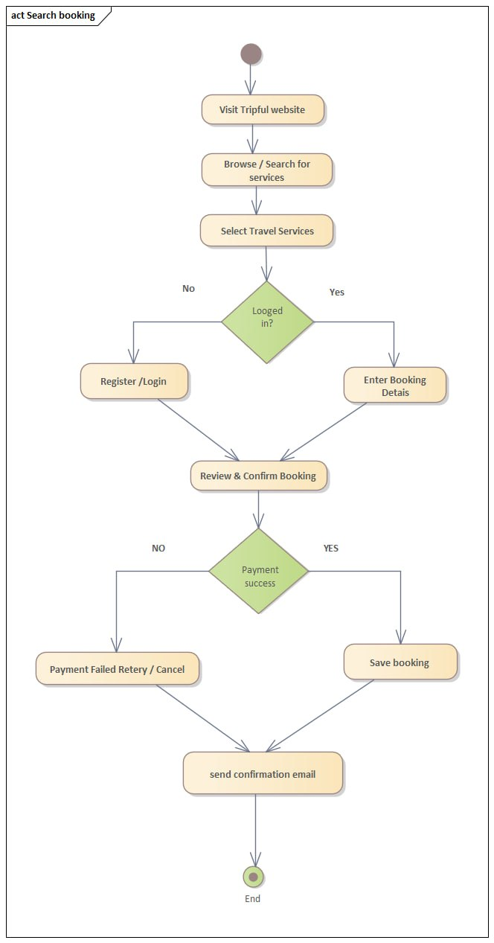

5.3.4 User Registration Activity Diagram

Introduction
This flowchart shows how users register with Tripful travel agency’s web site. The flowchart shows a straightforward linear process however, at one point in time during the registration process, the user’s registration will be reviewed and either approved or not. This diagram illustrates a typical way to represent a user’s interaction with an application. It can also help developers and business process managers understand user needs and requirements.

Narrative Description
When a user decides to use a Travel site, they will visit the website to sign up for a new account and fill out the Registration Form & (if) submit it for registration.

The initial step in the process is filling out the Registration Form and attempting to submit it for registration. This step introduces the system's most important Validation Check, which is depicted as a decision diamond (or ? diamond) labelled "Valid?".

This decision is based on the validity of the user's registration data and will dictate how the process will flow from here:

A. If the data entered into the registration form is INVALID (the "No" path), the system will not continue with processing the registration. Instead, it will direct the user to the appropriate error message and provide an opportunity to register again, returning to the previous stage (#Registration Form) so that they can update and resubmit their registration information.

B. If the user's registration data is VALID (the "Yes" path), the system will complete the registration process by sending the user a Confirmation Email, and will mark the end of the registration (successful registration).

In fact, this flowchart contains a single Validation Loop to ensure that there is only one opportunity to fully process the Registration Form, along with providing immediate feedback and an opportunity for the user to correct any errors prior to processing.

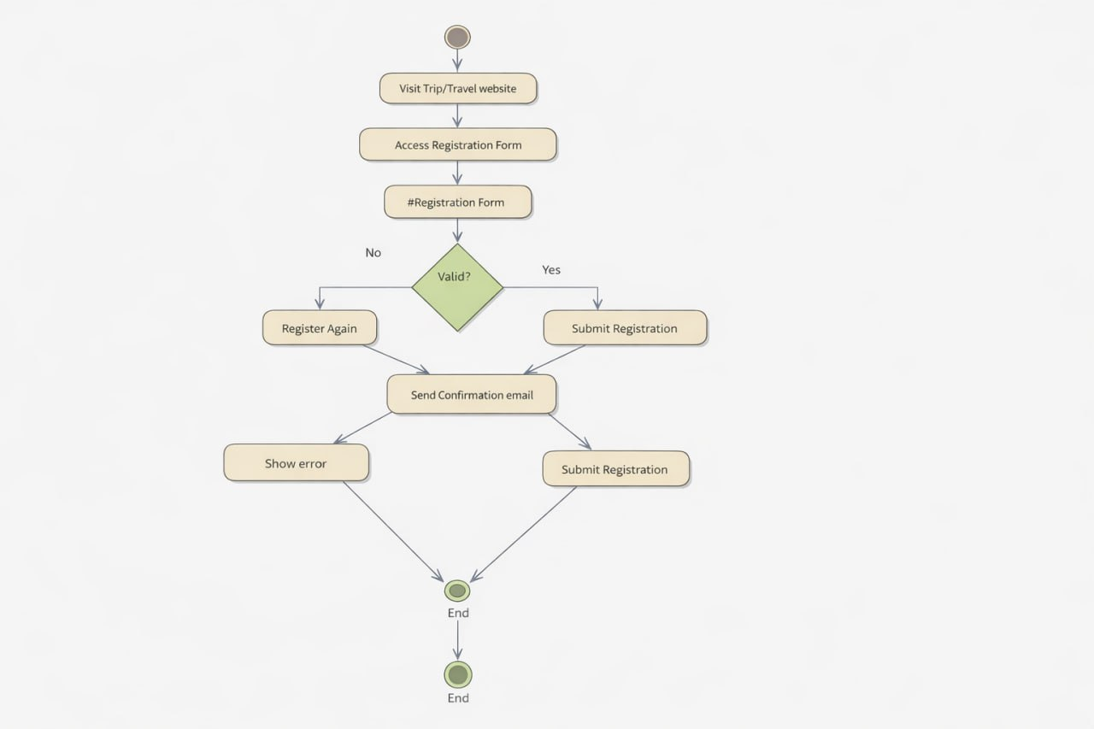

5.3.5 Review Submission Activity Diagram

Introduction
The diagram shows how a user navigates through the steps needed to read and submit a review on the Tripful travel site, while showing the decision making points based on the user's intent or whether the user is logged in to please the Tripful travel web site.

The Activity Diagram also clearly displays what a user sees (activity), where they begin and end (workflow), the prompts that guide the user at each step of the process; and how these decisions lead to a successful review submission.

Narrative Description

The process Starts when a user decides to Visit Tripful Home Page. Their journey toward submitting a review begins with them actively scrolling down to find the "Recent Reviews" Section.

Once there, the user typically reads existing reviews. This step leads to a key decision point: Want To Add Review?

If the user's answer is NO, they simply continue browsing the website and the activity for this path comes to an END.

If the answer is YES, the process continues to another critical system check: Is Logged [In]?

If the user is not logged in (NO), the system shows a login prompt. The user must then click "Login" button and complete the login process before proceeding.

If the user is logged in (YES), the system immediately shows a review form.

After any required login is complete, the user proceeds to fill the review form and then click submit. This action triggers the system's final actions: it saves review to the database and makes the review appear in the "Recent Reviews" section for other users to see.

The workflow then reaches its final END state, signifying the successful completion of the review submission cycle from initial visit to published feedback.

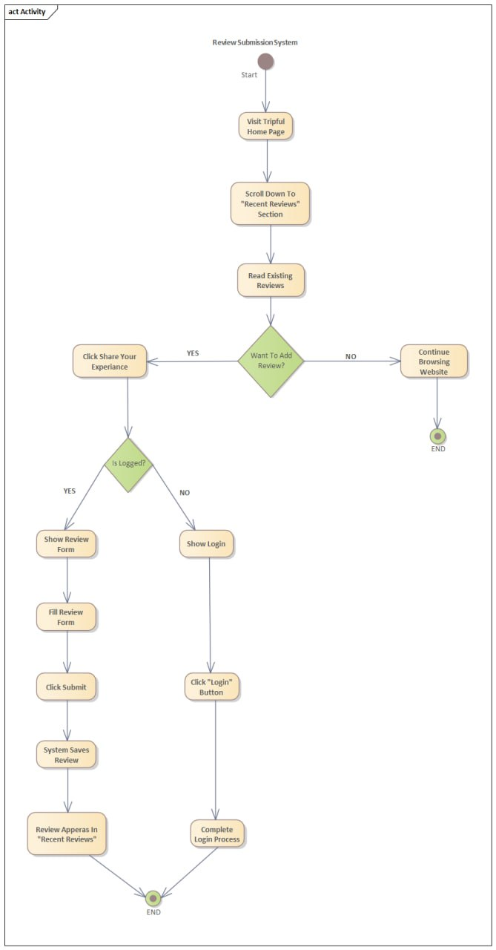6. Reference

- ISO/IEC/IEEE 29148:2018
- IEEE Standard 830-1998
- Software Requirements (3rd Edition) by Karl Wiegers and Joy Beatty
- AltexSoft's Guide to SRS
- Ethiopian Airlines Website
- Telebirr and Chapa API Documentation

Appendix: Requirements Gathering Documentation
The requirements for the Tripful website were identified to serve customers, travel agents (staff), and system administrators. The following tools are typically used to elicit such detailed specifications:

1. Stakeholder Interview Questions
Interviews were conducted with travel agency management to define the project's Purpose and Scope.
- Goal-Oriented Questions:
  - What are the primary goals for the Tripful website? (e.g., making booking as easy as ordering food online) .
  - What features should be excluded from the initial release? (e.g., physical ticket mailing or direct airline computer communication) .
- Role-Specific Questions:
  - What specific tasks should a "System Admin" perform? (e.g., managing users, backing up data, and system monitoring) .
  - What capabilities do "Travel Agents" need? (e.g., adding/editing holiday packages and seeing all bookings) .

2. User Requirements Questionnaire
To understand the needs of "Registered Users" and "Guests," the following questions help define Functional Requirements:
- For Guests: What information do you need to see before creating an account? (e.g., browsing destinations and searching flights/hotels) .
- For Registered Users: How would you prefer to handle a forgotten password? (Findings: secure email link) .
  - What information should be in your booking history? (e.g., status of bookings and ability to remove them) .
  - Would you like to provide feedback on your trip? (Findings: submitting reviews and ratings) .

3. Technical & Constraint Checklist
Questionnaires for developers and IT staff helped establish General Constraints and Non-functional Requirements:
- Compatibility: Which browsers must the system support? (Target: Google Chrome and modern browsers) .
- Security: What standards must be met for payments? (Results: PCI DSS compliance and no local storage of card details) .
- Connectivity: Does the system need an offline mode? (Results: No, a reliable internet connection is essential for all operations) .

4. Interface Requirements Survey
This was used to define how the system interacts with external entities:
- Payment Gateways: Which local payment methods are preferred in Ethiopia? (Results: Telebirr and Chapa) .
- Third-Party APIs: What external data is needed? (Results: Mapping services for hotel locations and email services for confirmations) .

